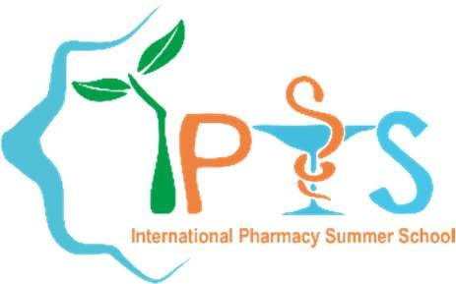
INTERNATIONAL PHARMACY SUMMER SCHOOL

SIZED RECENT PHOTOGRAPH
Association of Pharmacy Student Department of Pharmacy
Faculty of Medicine and Health Sciences Universitas Muhammadiyah Yogyakarta Yogyakarta - Indonesia
Email: ipss@umy.ac.id Website: https://ipss.umy.ac.id/

STUDENT APPLICATION FORM IPSS 2022
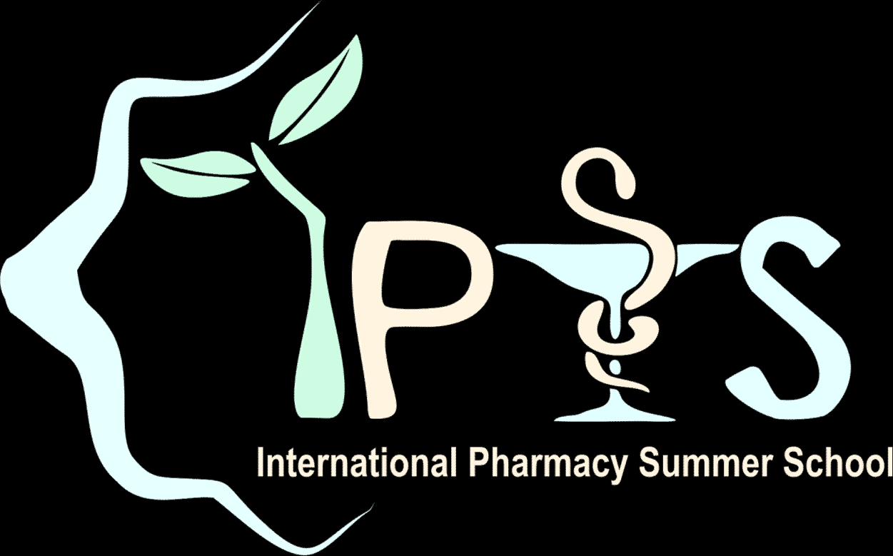
This year IPSS will be held on 16th July 2022 – 20th July 2022. Please fill the form below completely.

PERSONAL DETAILS
Full Name : _ _

Instant Messenger ID:

_ Preferred Method of Contact :

Nick Name :
Gender : [ ] Male [ ] Female
Birthday : Nationality : _ _ Address : _
_
_
[ ] Phone [ ] Email
University :
_
_ School Attended : [ ] Pharmacy
Level : [ ] Student*
[ ] Graduate

_ *Year Level in 2022 : _ Home Number : _

Mobile Number: _ Email Address :
Native Language/s : Second Language/s :
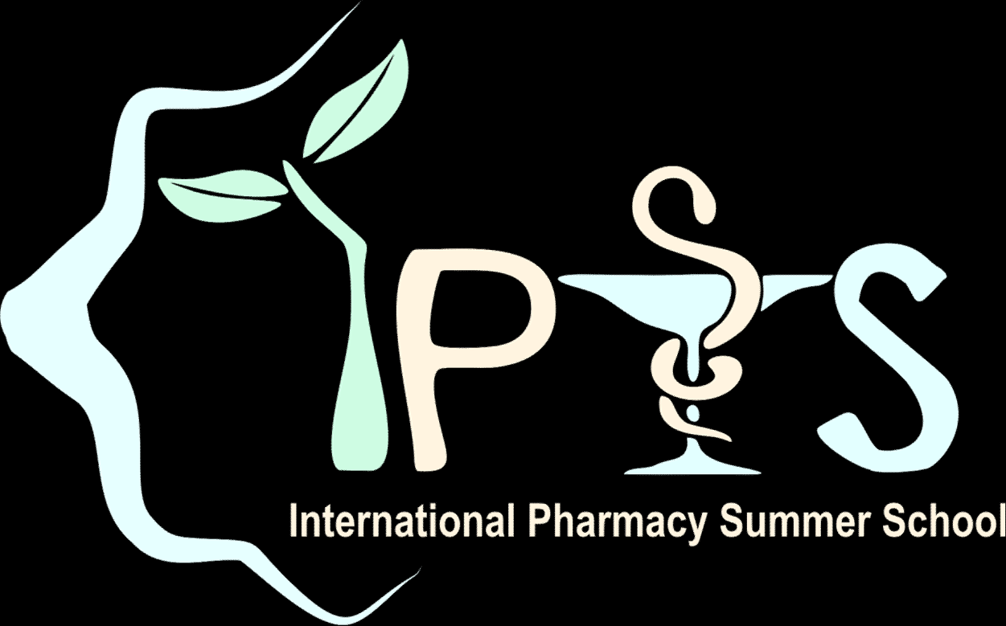
SUMMER SCHOOL EXPERIENCE
is there any pharmacy summer school you have attended before? [ ] Yes – Please specify [ ] No

Name | Topic | Year | City & Country

IPSS 2022 SURVEY
How do you rate your knowledge in the field of Indonesian indigenous medicine in modern medical treatment?
[ ] None, but I’m eager to know [ ] Beginner* [ ] Experienced in this field*
*If you check one of the boxes with this (*) sign, please state briefly why you rate yourself in that level.

How did you hear about IPSS 2022? (You can sign more than one checkbox) [ ] Friend/previous IPSS participant
[ ] Email
[ ] Mailing list, please specify
[ ] Faculty
[ ] Poster
[ ] Leaflet
[ ] Website (including Google search)
[ ] Publication in Pharmacy Conference
[ ] Others, please specify

MOTIVATION AND EXPECTED OUTCOMES
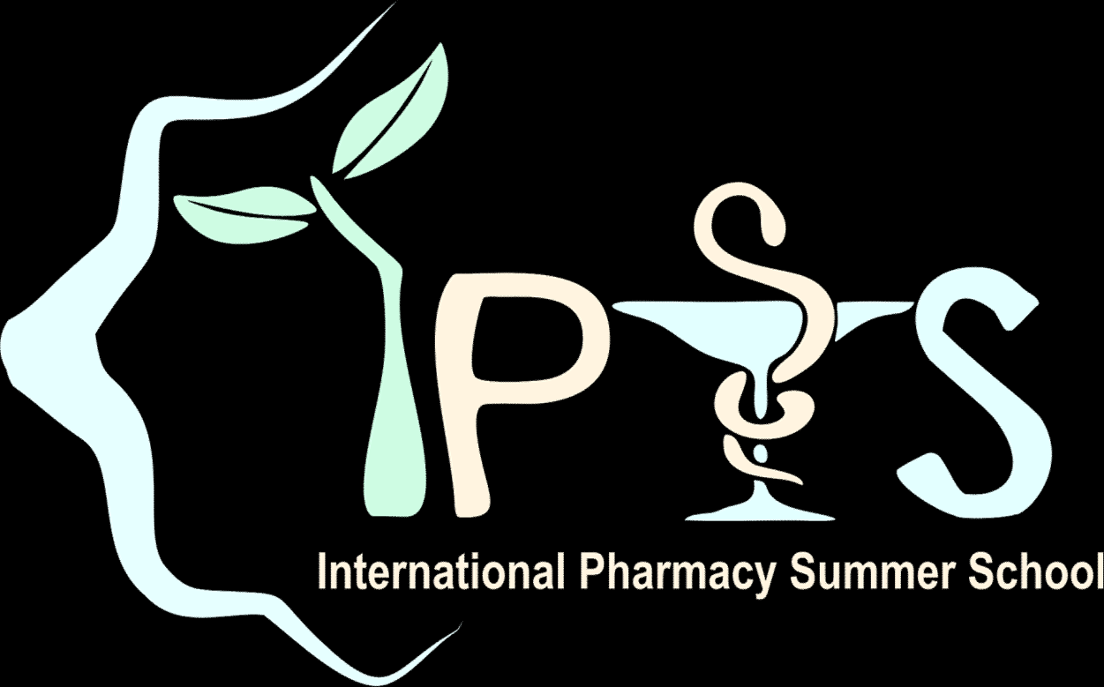
Motivation letter:

We are very pleased if you could state briefly your expected outcomes by joining IPSS 2022.

(place), (date), 2022 (Signature Here)

Please print this form after you fill in its entirety and sign it with written signature. Send a colour scanned document of this form to: ipss@umy.ac.id, and bring the original form when you join this program.

